

#### 22X23mm Coreless Brushed Series

**SPECIFICATIONS:**

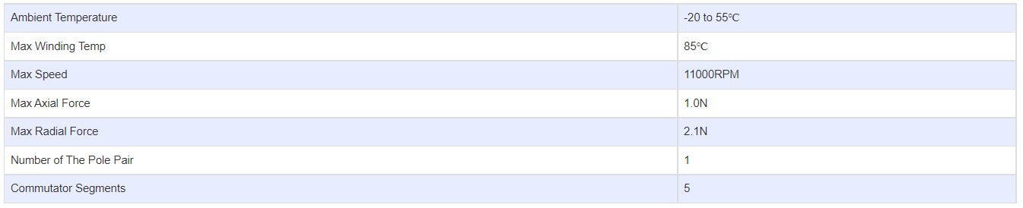

**SUBMODELS:**

*The following are common submodels for the LDO-CL2223 series.*

